EXPERIMENT 16

AIM:
SIMULATION AND ANALYSIS OF UNIFORM AND NON-UNIFORM QUANTIZATION USING MATLAB

SOFTWARE REQUIRED:
MATLAB Simulation

PROGRAM:
Clc;
Clear;
Close all;

T = 0:0.001:1;
X = sin(2*pi*5*t);
L = 8;

% Uniform quantization
Xmin = min(x);
Xmax = max(x);
Delta = (xmax-xmin)/L;
Xu = xmin + delta*(floor((x-xmin)/delta)+0.5);
Xu = min(xu,xmax);

% Non-uniform quantization (mu-law)
Mu = 255;
Y = sign(x).*log(1+mu*abs(x))/log(1+mu);
Yq = round((y+1)*(L-1)/2);
Yq = 2*yq/(L-1)-1;
Xn = sign(yq).*( (1+mu).^abs(yq)-1 )/mu;

% Plot signals
Figure;

Subplot(3,1,1);
Plot(t,x);
Title(‘Original Signal’);
Grid on;

Subplot(3,1,2);
Stairs(t,xu);
Title(‘Uniform Quantization’);
Grid on;

Subplot(3,1,3);
Stairs(t,xn);
Title(‘Non-Uniform Quantization (Mu-law)’); Grid on;
GRAPH:
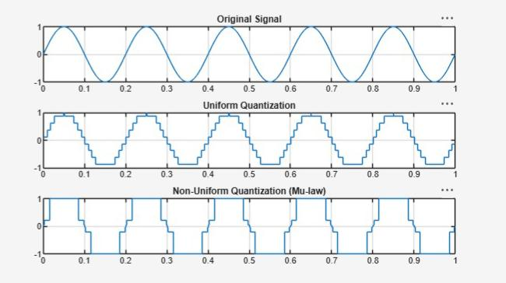
OUTPUT:
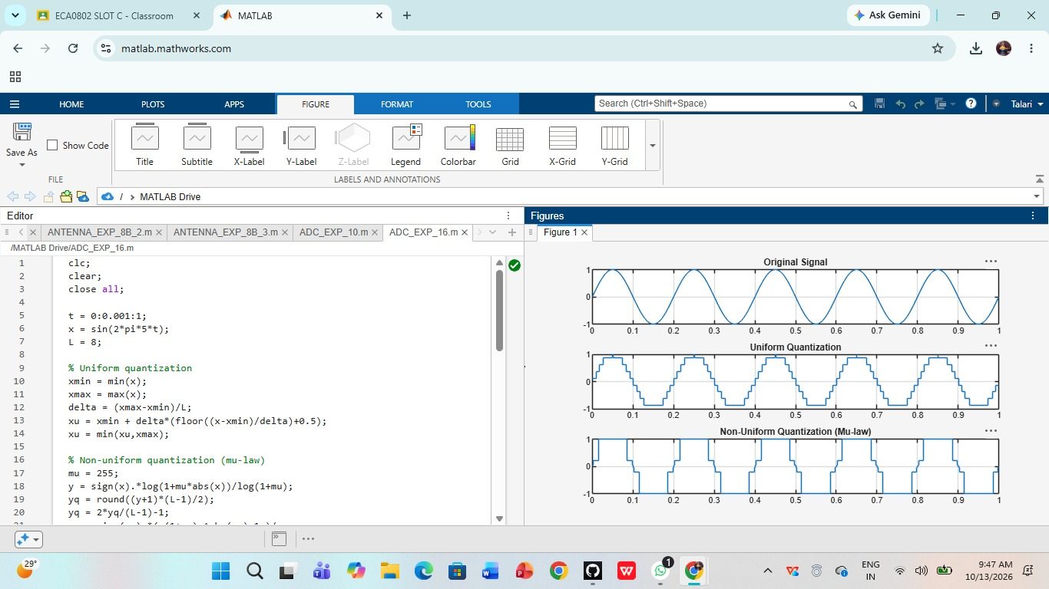
RESULT:
Uniform and non-uniform quantization were successfully simulated using MATLAB. Non-uniform quantization improved the representation of low-amplitude signals.

